Monsters VS Monster Girls Character Roster

Vampire Girl
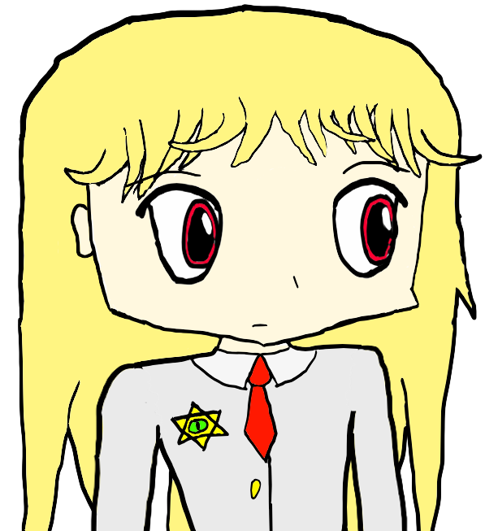
Species: Vampire
Divine Weapon: The Impaler of Unrepentant Sinners
Nationality: Neapolitan (Italian)
Blood Type: Whatever blood she sucks from her victims (possibly all of them?)
Likes: Getting revenge
Dislikes: Garlic, silver, mafiosos
Vampire Girl is driven by her vendetta towards monsters, being determined to totally wipe them out from existence. She was once a European noble from the Middle Ages whose family belonged to a Mafia-like organization. Her family possessed a divine item called the “Soul Gem”, which is imbued into her current divine weapon, the Impaler of Unrepentant Sinners. This divine weapon is said to contain 108 souls in its soul gem, and it is capable of banishing demons to Hell, as well as sending any wicked souls it slays to Hell as well.
Vampire Girl is vengeful towards monsters because they reflect the evil that was apparent in the mafia members that slayed her family. Before the Great Curse, Vampire Girl's family was in possession of its heirloom called the Soul Gem. This coveted item was prized by mafia lords across the lands, and each were desperate to somehow procure this beautifully cut gem. When her family fell into debt problems, the mafiosos that her family was under used the Soul Gem as a collateral...against the family's will, so they had stolen the Soul Gem and slain as many of Vampire Girl's family members as they could find so no one would be responsible for inheriting the Soul Gem. An enraged Vampire Girl began her vendetta against the mafia once she found out about this heinous act, acquiring the Soul Gem in the process and trapping the lost souls of 108 members of the mafia inside the Soul Gem.
Sometime along the way, Vampire Girl had the Soul Gem fashioned into the divine weapon, the Impaler of Unrepentant Sinners, praying to God to grant her the power to become His executioner of the damned, should the world warrant one. God indeed had this as a plan for her, although Vampire Girl doesn't actively see herself as God's tool in the great battle of Armageddon...
As a vampire, Vampire Girl is amongst the most powerful of monsters that exist. Vampires have many strengths, but on the other hand, they have many weaknesses that counter those strengths. Amongst their strengths include super speed, super strength, and inherent magical ability, making them fearsome creatures to behold. Among their other abilities include spreading bat wings with which they could use to fly, as well as the ability to turn into a bat. Some vampires have more unusual abilities, although Vampire Girl is pretty typical. While they are indeed very strong, a vampire has limitations, including but not limited to weakness to sunlight, running water, and silver. In addition, they must consume some volume of blood over some basis, although the volume and the frequency differs from vampire to vampire. A common sign of ahematosis (disease of lack of blood sucked recently) is the amplification of vampire weaknesses, increased thirst for blood, muscle weakness (they drop to a level comparable to a human in terms of strength, but never below that unless they have caught another disease), increased susceptibility to human diseases (normally, they are immune), and general malaise if the increased motivation for blood does not help the vampire get closer to a source of blood. In this setting, vampires are something in between demons and undeads in terms of their abilities and weaknesses.

Cyclops Girl
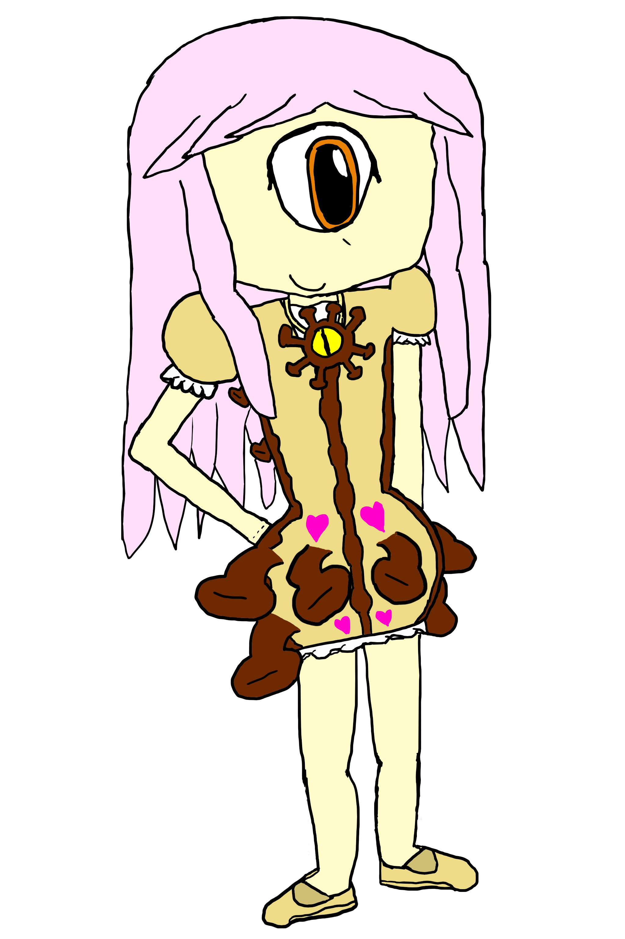
Species: One-headed Bipedal Cyclops
Divine Item: Eye of the Beholder
Nationality: American
Blood Type: AB
Likes: Her friends
Dislikes: Dishonesty
Unlike most other examples on this list, Cyclops Girl has been a normal girl with a normal family for much of her life. However, she was not without her share of tragic events that had occurred throughout her life, such as the death of her parents leading her to live under her older sister. She holds her older sister to high esteem and in many ways even treats her as a good friend or mentor.
Cyclops Girl has thankfully matured into a better person through her development, but the status quo wouldn't remain for long. One day, her sister started growing more and more irritable and this bothered Cyclops Girl; she wanted to get to the bottom of the problem, but nobody was able to figure out what was causing her sister's aggravation until it was too late. Her sister's mental health started to decline rapidly as she grew insane, and ultimately killed herself. Near her own sister's corpse, Cyclops Girl found a single, yellow eye that stared through her, as if it was staring into her soul. Despite her grief, Cyclops Girl was compelled to approach the eye and pick it up, and after she did, the eye started speaking to her and referred to itself as the Eye of the Beholder. It stated that it had the ability to look into anybody's soul and told Cyclops Girl not to let go of it, or she may lose her life.
Cyclops Girl survived the death of her sister and continued to live on, being forced to work and live on her own despite her age. She had been through highs and lows and has made new friends; however, every one of her friends would eventually go insane and kill themselves in her presence. Cyclops Girl was traumatized and implicated that it was the Eye that was causing this to happen. Cyclops Girl felt trapped; if she got rid of the Eye, she may die, but she wanted it to stop harming her friends. Depressed that there was nothing she was able to do about this, she threw the Eye has far as she could and ran away from it, never wanting to have anything to do with it again...
While initially feeling fine, Cyclops Girl felt worse and worse and dwelled on the thoughts of her dead family and friends. As if this wasn't enough, one day, she had noticed that her vision was “splitting” and people were looking at her weird, calling her a “monster” or a “freak”. She was indeed able to get a hold of a mirror to see that she had one eye. Horrified by her new look, she ran away, but monsters followed in her footsteps as they had discovered her moment of weakness and were poised to attack. Cyclops Girl had run to the Cliff of Desolation and get ready to do the deed, but...
Vampire Girl had emerged from the shadows to fight the monsters that were attacking her, and had found the Eye of the Beholder. Vampire Girl convinced Cyclops Girl that not all is lost despite what happened, and it is still possible to rebuild society and make new friends in the process. Cyclops Girl regretted having almost been driven to the edge and is grateful to Vampire Girl for saving her. The two had pledged to work together to accomplish Vampire Girl's goal and be comrades for as long as they live.
Having survived the death of many of her friends and family, even with the Eye of the Beholder that has restored stability to Cyclops Girl, ever since Vampire Girl had saved her, Cyclops Girl has defied the gravity of tragedy and has tried to remain optimistic. This is because Cyclops Girl has hope—hope for the future. She sees the glass half full, and refuses to believe that the new state of the world is the end of all things. Even despite her monstrous one eye, she has kept her disposition and has decided that she would use her powers for the good of the world if she has to.
Cyclops Girl represents the poorly understood family of monsters called the cyclops. Cyclops come in varying shapes and sizes. Despite these differences, all cyclopses share a few traits in common, including one, large central eye (even if other eyes are possessed) and an ability associated with this eye called “Evil Eye”, which typically causes fear and weakness in those afflicted by it, although Evil Eye can cause different effects depending on the cyclops. Cyclops Girl has the typical version of Evil Eye at first. There are different species of cyclops that exist, including the floating cephalocyclops (also called the “Evil Eye”), the one-headed bipedal cyclops (this is the species that Cyclops Girl belongs to), and the multi-headed bipedal cyclops (also called ettins). Cephalocyclopses are the only cyclopses that have the natural ability to fly.
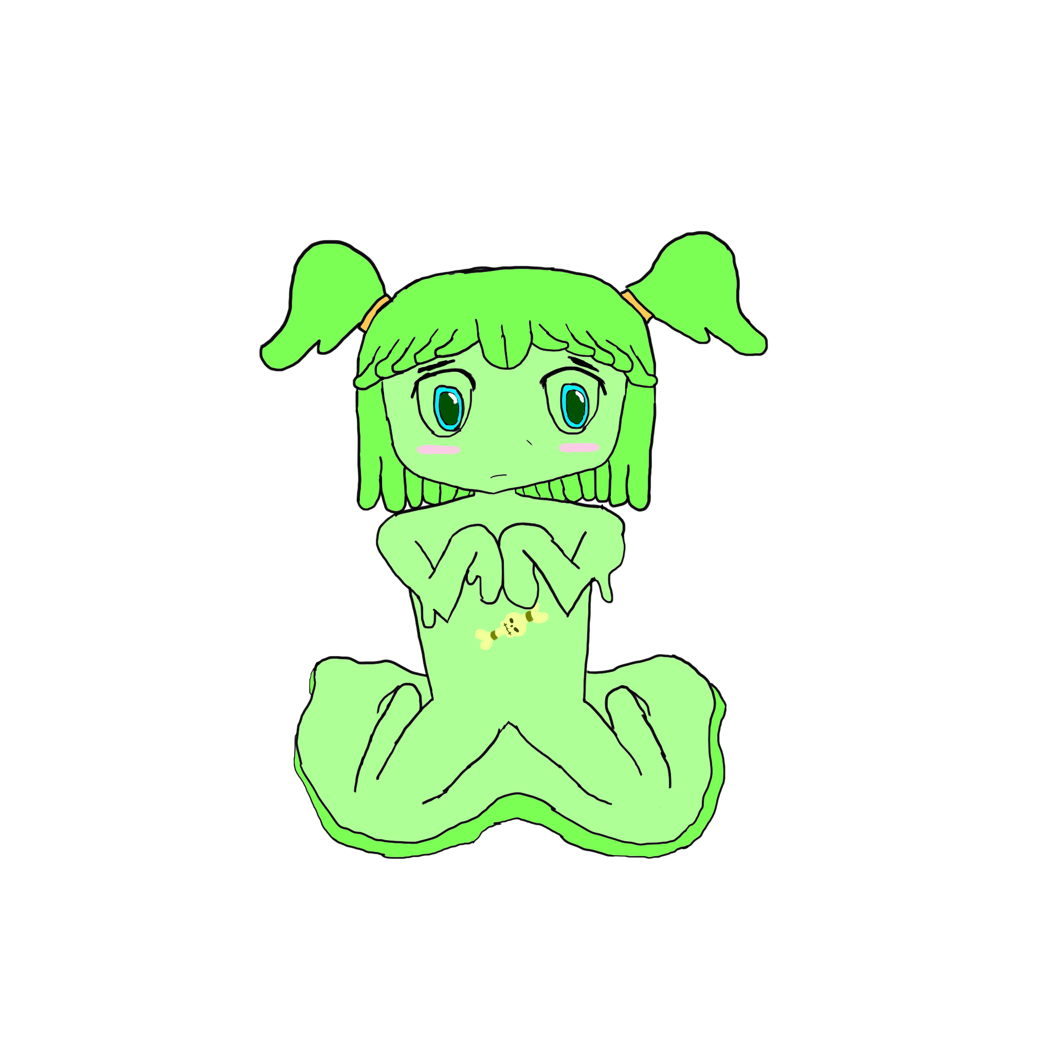
Slime Girl
Species: Green Slime
Divine Item: The Wishbone
Nationality: American
Blood Type: G (Green)
Likes: Sleeping
Dislikes: Being put in embarrassing situations
Before the Great Transformation, Slime Girl was a shy high school student who had few “friends”. Slime Girl was rather awkward in social interaction and this caused her peers to view her as weird, so she was bullied for her difference. She suffered a volley of physical and verbal attacks throughout her school life, and Slime Girl became depressed as a result. This hurt her self-esteem, and over time, she had come to view her life as worthless and was getting ready to take her own life. Her own parents contributed to her depression, as they were barely any better than her bullies, rarely being at home when she needed them and being busy even when they are home. All Slime Girl needed to do was gather the will and the tools to do the deed, and her pain would be no more...
After facing a severe beating and running away in order to finally end it once and for all, Slime Girl had encountered an item called The Wishbone, which had promised to grant her a wish at the expense of “someone's life.” Right then and there, Slime Girl wished that she would stop being bullied, and her wish came true...in the most perverted way imaginable. Suddenly, the people that victimized her the most were found dead under suspicious circumstances, and while the investigation didn't specifically incriminate Slime Girl, a new wave of peers began to resent Slime Girl out of suspicion. Once again, they started to bully her, but more viciously than they did last time. At the same time, the Great Transformation was occurring, and those bullies that were administering the beating had themselves transformed into monsters. Slime Girl wasn't given much of a respite as she was beaten to a pulp; her flesh began transforming into disgusting green slime. She was getting ready to make her final wish, to end it all so that the pain would stop, but in order to do that, she needed to spill the Wishbone's dust for the wish to be fulfilled, and it had become stuck in her viscous form. She couldn't even put herself out of her own misery, she seemed resigned to be tormented by her bullies turned monsters for eternity...
Thankfully, Harpy Girl, a fellow peer that rarely crossed paths with Slime Girl, intervened to defend Slime Girl. Harpy Girl was never there before, but she has promised that in this world that tends to hate anything that's “different”, she will always be her friend. Together, the two were able to beat the monsters back, although Slime Girl still struggles with her self-esteem, but now she at least has a friend that she can lean on.
Slime Girl is very shy, having been a victim of constant bullying for much of her life. It is likely that she has a social anxiety disorder that was never diagnosed or treated, so she struggles to interact with people, although her friends make her feel a little more comfortable. This behavior is very passive, and she is unable to get what she truly wants because of this; she is unable to speak up. Harpy Girl helps her by encouraging her as opposed to pressuring her. The two have grown very close at this point and one probably cannot survive without the other.
Slime Girl is a green slime, which is just one genus in a large family of slimes. Slimes come in all shapes and sizes and are distinguished mostly by their ecological niche and color. Even amongst the green slimes, only a few differences exist between the many otherwise identical green slimes and only a trained monsterologist would be able to point out the differences. It is not known exactly what kind of green slime Slime Girl is, but her viscous, slimy flesh is highly corrosive when she wants it to be, capable of breaking down wood and metal with ease. Just like other slimes, these properties make her highly resilient and a tough enemy to beat due to her alien biology. Green slimes usually live in warm, moist environments like the rainforest where food is plentiful, while blue slimes usually live nearby areas of strong magical power, feeding off ambient magical energies when they could or, failing that, feeding off beings or items of magical power that they can detect. Most slimes are mindless creatures, but Slime Girl is an exceptional example of one that's not mindless.

Centaur Girl
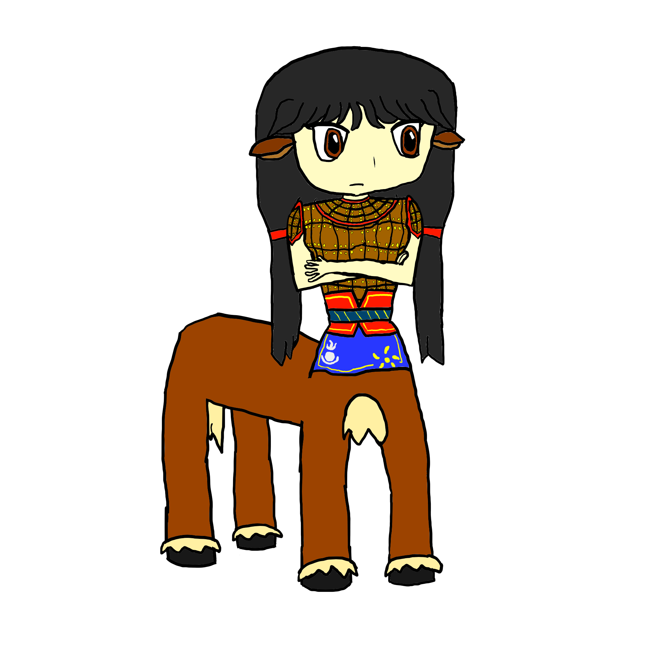
Species: Centaur
Divine Weapon: Voluntas the Greatcleaver
Nationality: Mongol
Blood Type: A
Likes: Fighting evil, sparring in general
Dislikes: Cheating
A long time ago, Centaur Girl's father, the Great Khagan, had united the warring tribes of the steppe and had mobilized them to embark on the greatest conquest that the world had yet known, becoming the most feared name from the farthest reaches of Ireland to the petty kingdoms of Oceania. One by one, the various great powers of the time fell to the Mongols, with countless innocent lives lost and plagues spreading across the world, killing many of those who managed to survive. The Great Khagan's empire is on the heels of world domination at the moment...except he has no sons to inherit his great empire, so he has fashioned his daughter to be his heir, and that girl is Centaur Girl. She has inherited the Great Khagan's hot-blooded and aggressive personality, and the Great Khagan himself had sent her out on dangerous missions in order to assist in his conquests.
One day, Centaur Girl was sent on a mission to extract tribute from the princes that ruled Russia who had refused to pay up. One of the princes had managed to kidnap Centaur Girl's little sister and take her hostage, creating a dilemma for Great Khagan. If he took aggressive action towards the prince, he could execute her. On the other hand, Great Khagan was motivated by his own greed and wanted money that he can use to further expand his empire, so he sent Centaur Girl on this mission anyways. Centaur Girl loves her little sister, however, and has secretly decided to disobey her father's orders and find a way that she can rescue her little sister using the army that she's been entrusted with.
After her spies reported to her with information on the whereabouts on her little sister's whereabouts, Centaur Girl acted upon this information to head to that place and extract her little sister with as little bloodshed as possible. As she headed to that place, the skies grew dark as the Great Transformation was beginning, and before she knew it, her own men had been transformed into monstrous centaurs, a grotesque fusion of the horse they were so reliant on, and themselves. Centaur Girl herself underwent a transformation as well, but despite this, she still retained her exotic beauty. These aggressive centaur warriors were intractable and difficult for her to control, but despite this, she has attempted to get them to distract the forces of the prince, although this was ineffective as the centaurs quickly fell into infighting. Regardless, she had used this opportunity to try and save her sister and perhaps retreat and regroup after the unusual and terrifying events that had occurred lately.
Centaur Girl's divine weapon is Voluntas the Greatcleaver, a mighty greataxe fashioned from meteorites. The Great Khagan ordered the creation of such a weapon by the greatest blacksmiths across the lands and had requested the Great Sky to bless this weapon. The result would be an intimidatingly massive and heavy greataxe that none of his own warriors, or even himself, could wield. The Great Khagan decided instead that he would keep this axe for a decisive battle, just in case himself or any of his warriors would ever have the strength to wield it. After the Great Transformation, only Centaur Girl has proven that she is strong of body and will enough to wield this weapon. The greataxe is capable of slicing through almost any material with ease, although using it at full strength can be tiresome.
Centaur Girl is resolute and likes fighting, but only if it's for a good cause such as sportsmanship. Centaur Girl cares deeply for her father and little sister, and especially for her little sister, she wouldn't let anybody lay a finger on her. Despite what had happened to her sister, Centaur Girl is driven by her love and determination to get her back. Centaur Girl has not seen her father since the events of the Great Curse, and is worried about his welfare. Centaur Girl is notably quite stubborn and will go at great lengths to get her way. Being raised a warrior, Centaur Girl is not much for social interaction, although she respects other people as her equals.
It should be noted that monster centaurs are a highly aggressive and territorial species of monster, compared to how they are traditionally depicted in fiction. Monster centaurs are generally not attractive, although they appear to be highly muscular men with large horse bodies. Monster centaurs possess great strength and are capable of carrying many times their own weight due to their frames. They are also difficult to tire out, and possess a lot of stamina, making them ideal fighters and soldiers. Monster girl centaurs, such as Centaur Girl, possess a lot of the same strengths as monster centaurs, and there seems to be a higher proportion of monster girl and monster guy centaurs per capita for monster centaurs than there is for any other monster race. Monster girl centaurs love to fight, but they are not as aggressive as their monster centaur cousins, often disdaining needless bloodshed and territorial expansion.

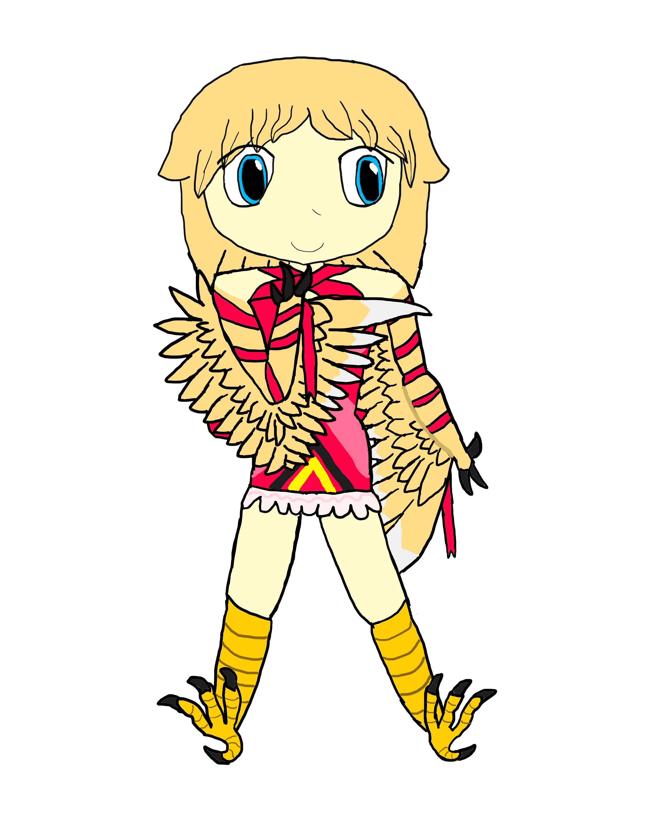
Harpy Girl
Species: Harpy
Divine Item: Ribbon of Fate
Nationality: French
Blood Type: B
Likes: Singing
Dislikes: Exclusion, dissonant tones
Harpy Girl is a foreign exchange student from France that had come to the United States in order to receive training in her singing and acting skills, as Harpy Girl has always been interested in the performing arts and grew up wanting to be like the idol singers that inspired her since she was young. In the high school she went to, her charisma and her beauty quickly attracted people and she became popular, becoming well-acquainted with many of her peers at the time. While she wanted to be friends with everybody, she also sought attention from her peers and these two goals tended to conflict with each other. Pressure had built on her to bully the weird and isolated kids in school, but she had tried resisting these temptations because she didn't want to hurt anybody's feelings. The result of this state of affairs was that while Harpy Girl was “friends” with “everyone”, she wasn't truly “friends” with anyone, so having nobody to lean on, she had been isolated for much of her school life. She would rarely get victimized or bullied, but at the same time nobody really cared for her and at worst exploited her in social gatherings.
Harpy Girl and Slime Girl went to school together. However, both girls were mostly in their own little worlds doing their own thing, and rarely would their orbits align, so they barely knew each other. Harpy Girl had always been aware, however, that Slime Girl has been a constant victim of bullying, and regretted what the others were doing to her, although Harpy Girl was too afraid to approach Slime Girl about this issue in order to be her friend. One day, however, this would all change, for better or for worse...
The Great Transformation was occurring, and the sky darkened as a shadow appeared to block much of the Sun's light. During one of the darkest days of school yet, the evil hidden within the hearts of many of the schoolchildren plagued their demeanors, and they began acting like monsters towards each other, and especially towards Slime Girl. One by one, each person and even the staff members transformed into grotesque monsters and attacked each other, but then they found that one of the objects of their hatred Slime Girl, was also transformed, but less so than they were. Out of jealousy and contempt, they began attacking Slime Girl and beating her to a miserable pulp. Harpy Girl, too, had transformed, but the other monsters had ignored her in order to take out their rage on Slime Girl. These creatures were despicable for their actions and Harpy Girl did not want to let this happen, so Harpy Girl went to defend Slime Girl and attack the monsters back while Slime Girl was defenseless. Harpy Girl promised Slime Girl that she would be her friend, and to do what she can to make it up to her for all those years of abuse she experienced and Harpy Girl did nothing to stop it.
Harpy Girl's divine item is the Ribbon of Fate, which is a red ribbon tied around her body that she may inscribe names onto. Once Harpy Girl inscribes someone's name to the ribbon and divines their fate, the name on the ribbon glows and becomes embedded into the ribbon, “sealing” that person's fate. It is unknown how such a divine item of great power works or how it can potentially be used, but it is likely to have limitations or even drawbacks to its use, although Harpy Girl is not aware of what these are yet.
Harpy Girl is loud and proud, even despite her transformation, although it is likely that she is not comfortable with her new appearance. Instead, she boasts her great singing ability for the entire world to hear...or at least, she thinks her singing voice is great. Harpy Girl has a confidence problem and doesn't know if her voice is really that good, so she often sings to get attention and fish for complements. Unfortunately, this has sometimes achieved the opposite effect, annoying others instead of getting them to complement her voice. Still, Harpy Girl knows when to stop and has managed to maintain acquaintances without getting on their bad sides.
Harpies are monsters best known for their territoriality and fierce protection of their young. Few harpies have joined Great Babylon's war effort, instead choosing to serve as mercenaries and even enemies of Great Babylon, preying on monsters and monster girls that pass near their nests. Harpies have a very strong ability to manipulate their own voice, and a few are capable of mimicking any voice or producing any sound. They often use this ability to attract prey before diving in for the kill with their talons. Harpy Girl has the ability to produce any song or any frequency range, but her voice is strongest in her natural range. Harpies are an all-female species, and how they mate is poorly understood, although all existing harpies and their young are derived from women and their young, and no new harpies have been produced ever since the Great Curse. This is merely an observation, as no one has been able to confirm otherwise that they are capable of producing young on their own. Harpies are amongst the more naturally attractive of monster species, although monster girl harpies tend to be cuter and more humanoid.

Octopus Girl
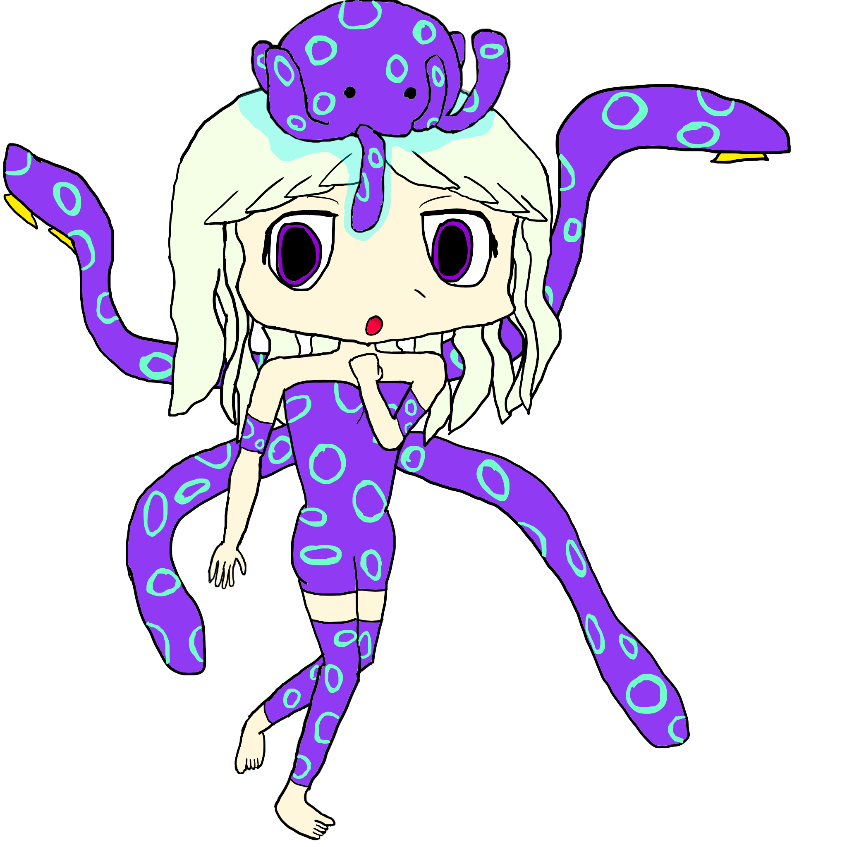
Species: Parasite-controlled human (Parasite: octopus-like creature??)
Nationality: Canadian
Blood Type: P (Poisonous-You do not want to touch this blood)
Likes: Meat
Dislikes: Being hungry
Back before the Great Transformation occurred, Octopus Girl was a sheltered and only child on the west coast of Canada (British Colombia) that lived with her father, who was a widower. Octopus Girl was very shy, and because she and her father lived so far from civilization, she rarely had contact with other people. Her family subsisted on fishing, so much of Octopus Girl's life has been at sea going deep-sea fishing with her father. Due to this isolated upbringing, Octopus Girl did not receive a formal education and grew up illiterate just like her father.
One day, however, while at sea with her father, the sky rapidly started gathering clouds and hurricane-force winds and rain suddenly started blowing through the area, without any warning. A giant octopus monster emerged from under the sea and grabbed Octopus Girl's father, dragging him underneath and presumably eating or killing him. Octopus Girl, on the other hand, was able to avoid the octopus monster, but instead, a small octopus-like creature fell on her head and started suffocating her. Before she knew it, she realized her thoughts were no longer her own, as this strange, alien creature had taken over her mind and her body...she made her transformation into what she is today, becoming a monstrous creature. The innocent look on her face has escaped her as she became a completely different being in a manner of speaking. However, despite this transformation, a shard of free will exists in her, a will to break free from this control, because deep down, she loathes what she has become.
Octopus Girl is now characterized mostly by the octopus-like parasite that has come to control her, which Octopus Girl calls “Cephalopod”. The true nature of Cephalopod is unknown and it appears to have the capability to completely take over Octopus Girl's actions and behavior if it doesn't get its way. Cephalopod has a high demand for energy and requires Octopus Girl to consume a large number of calories in a day, or else Cephalopod will force Octopus Girl to attack even her friends if it means getting her food. Despite this, Cephalopod, just like the octopus he seems to be, demonstrates a cold, calculating, and rational intelligence in its behavior. Cephalopod's control of Octopus Girl has given her a selfish and aloof personality, prone to taking jabs at other people's shortcomings if they annoy her. Octopus Girl is not above working with the other monster girls if it ultimately benefits her, which simply means having an infinite supply of food such as enemy monsters, although her motives appear to be limited to simply securing this. Octopus Girl cannot be said to be good or evil since she is a slave to her parasite. Nobody knows what might happen if she were somehow freed of Cephalopod's control, or if she would even be the same girl that she used to be anymore.
To be sure, nobody knows if Octopus Girl is really supposed to be an octopus. It can still be observed, however, that Octopus Girl bears many traits in common with the infamous blue-ringed octopuses belonging to the genus Hepalochlaena. One of these traits includes their potent venom, which is a powerful neurotoxin that will kill most creatures the size of a human and paralyze larger creatures. Octopus Girl secretes these toxins from her tentacles and the black parts of her skin, which includes her legs, her biceps, and her tentacles; the same chemicals seep from her black, tight, form-fitting exoskeleton on her torso. Octopus Girl is not in direct control of her tentacles, since each tentacle has its own brain, although she can still direct the tentacles to perform tasks, especially if Cephalopod supports these efforts. Octopus Girl may also retract a pair of tentacles to form a pair of arms temporarily, although these too are difficult to control directly and do not last long. They grant Octopus Girl some extra dexterity in manipulating fine objects or wielding weapons that tentacles do not allow for. Keeping the tentacles in this arm-shape is similar to holding one's breath; the longer this is performed, the greater the chance that the body will eventually force them back into their original shape (retracting the arms for a pair of tentacles again). The tentacles in their natural form are very strong and capable of lifting objects greater than 8 times Octopus Girl's weight or manipulating large objects with ease, although they have difficulty for finer tasks. In addition, just like the blue-ringed octopus, Octopus Girl is capable of changing the colors of her skin to act as camouflage or convey warning coloration, although the use of camouflage is ineffective if she is moving. The default color of the rings are sea green, but they turn a sharp azure when Octopus Girl is feeling threatened (a rare event, since Octopus Girl is usually able to handle most monsters and beasts far larger than herself).

Mushroom Girl
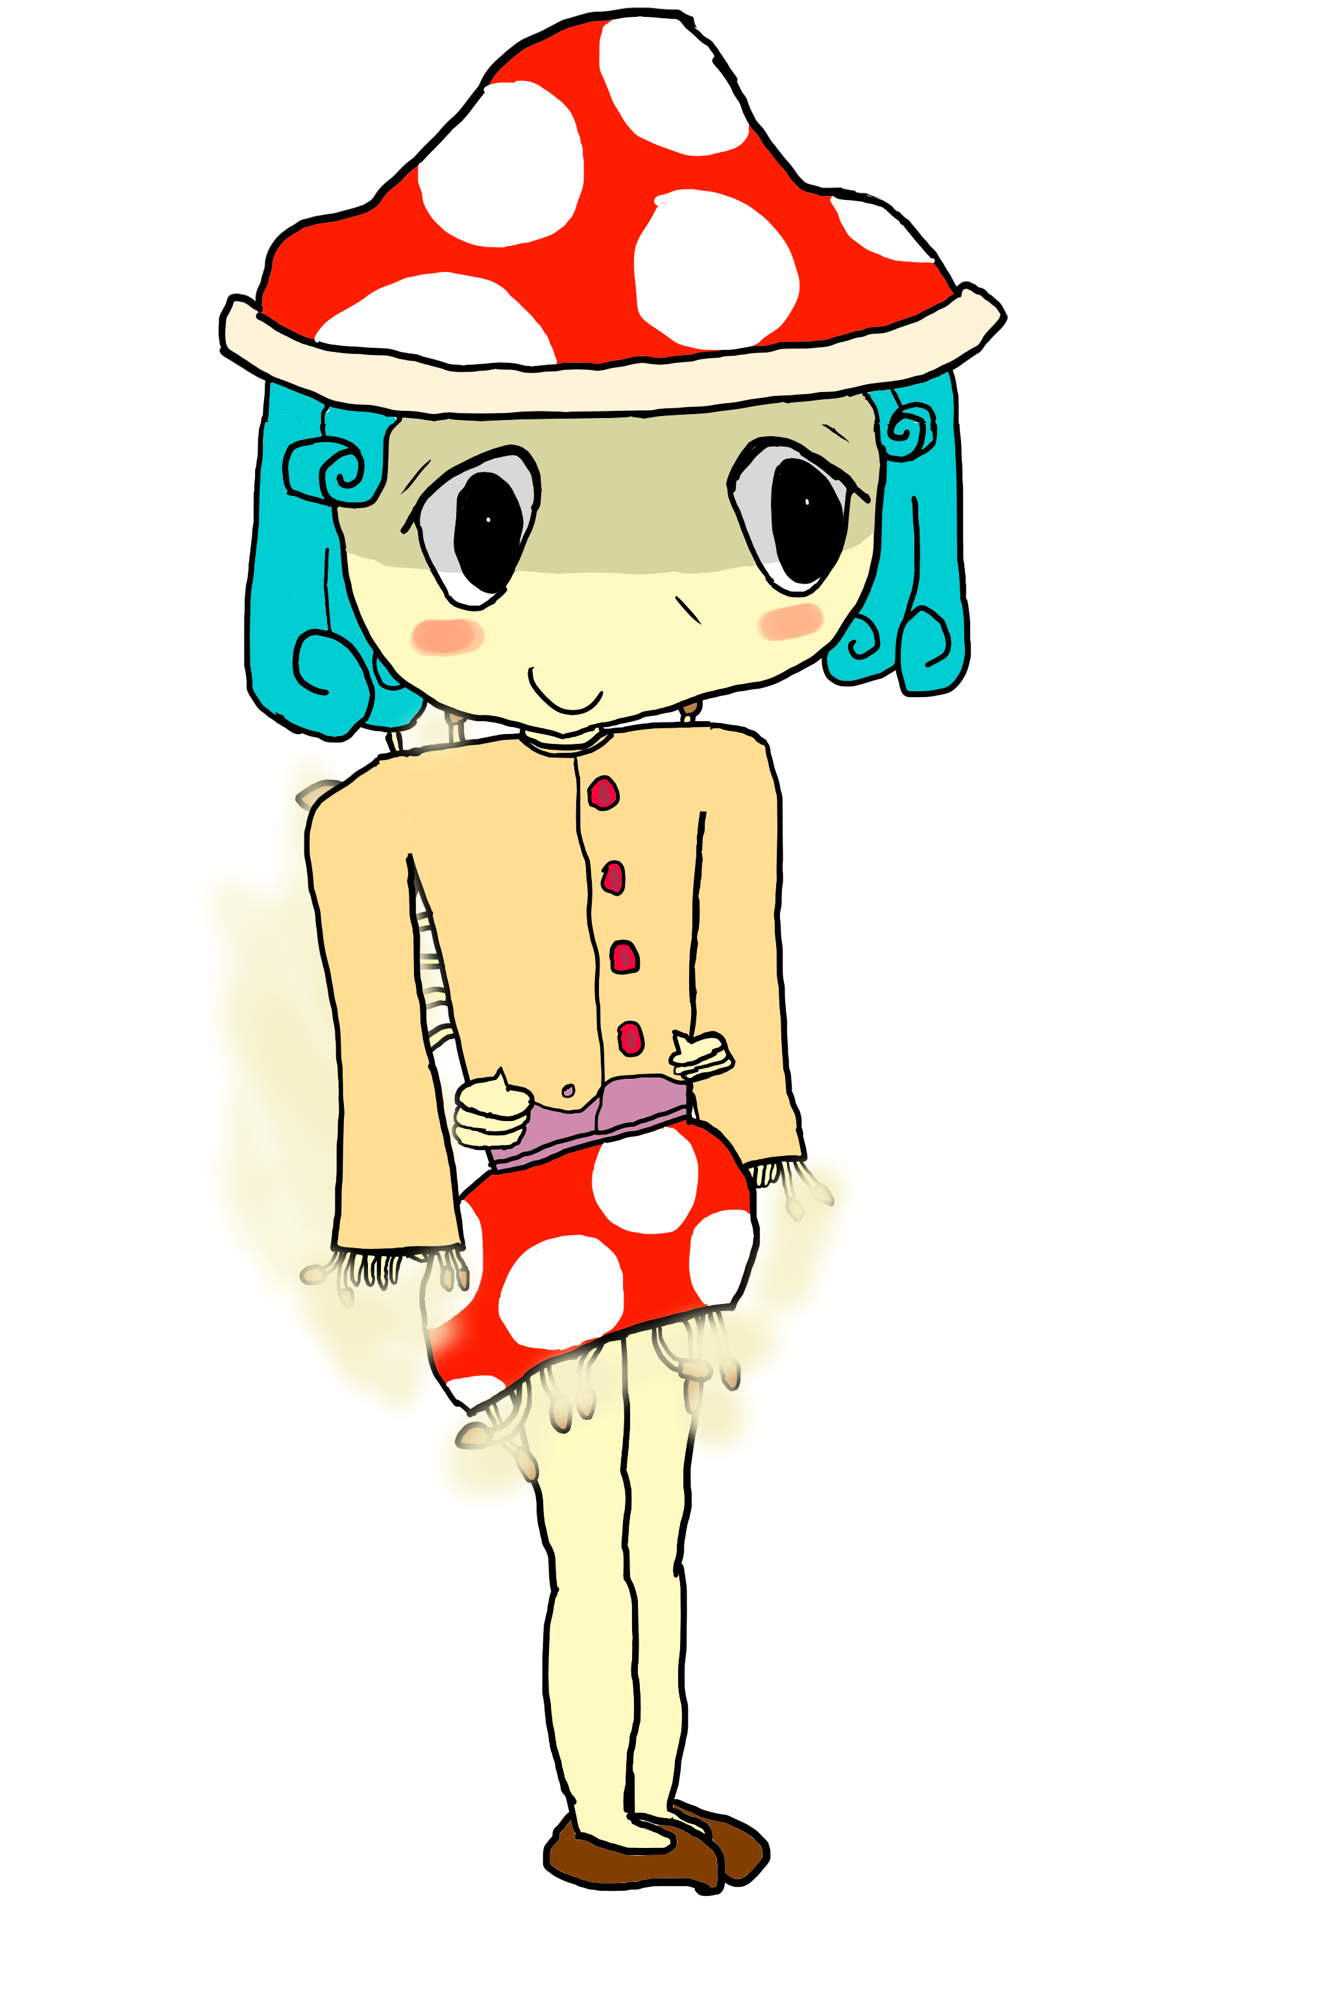
Species: Parasite-controlled human (Parasite: mushroom-like species)
Nationality: Spanish
Blood Type: Fungal
Likes: “Spreading the Seeds of Love”
Dislikes: Not being able to bring the wishes of the parasitized to fruition
Mushroom Girl is a former human that was infected by a fungal parasite that has irreversibly changed her look and behavior. Now, she exists only to spread this infection everywhere, oblivious to the consequences that those who are infected suffer. However, Mushroom Girl has embraced this new parasitized life; she loves seeing creatures and monsters become infected.
The top signs and symptoms of an early infection by Mushroom Girl are pale, clammy, sweaty, cold skin, light-headedness, low blood pressure, runny or stuffy nose, and feelings of impending doom. When caught in this stage, it is still possible for antifungal medication to destroy the infection without causing too much unacceptable collateral damage for the body, but over time the infection starts taking its hostages; multiple body systems; with it if it's not treated in time. Advanced stages of infection no longer have these symptoms present, but the subject eventually loses their mind and receives mental messages from other mushroom-infected beings. Rather, the subject becomes listless and incapable of expressing full emotion, acting more like zombies in a sense, and also mostly lose free will. In addition, mushrooms and fruiting bodies will start growing on the body of the affected individual until their immune system is completely taken over over the course of several weeks. These individuals are highly infectious towards non-infected individuals, and their spores can last for weeks on surfaces before decaying, so keeping away from these individuals and places they've been to is the best way to avoid infection other than good hygiene practices.
Mushroom Girl is unable to feel empathy through individuals that are not infected by her fungal plague, so she is unable to fully understand the wants and desires of others, even though she herself is a very empathetic individual. She sees herself as a “mother” and everybody that she infects as her “children”, wanting to bring her children every desire that they have despite being unable to most of the time. This causes her great stress sometimes, but she tries her best. When non-infected individuals scold her for her behavior, she is mostly unable to comprehend what they mean.

Dragon Girl

Zombie Girl
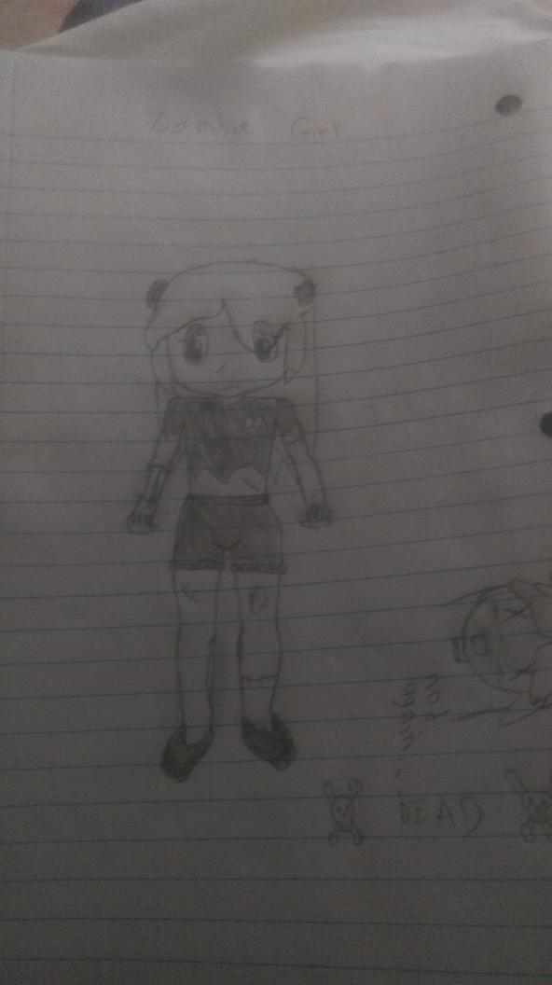

Scorpion Girl
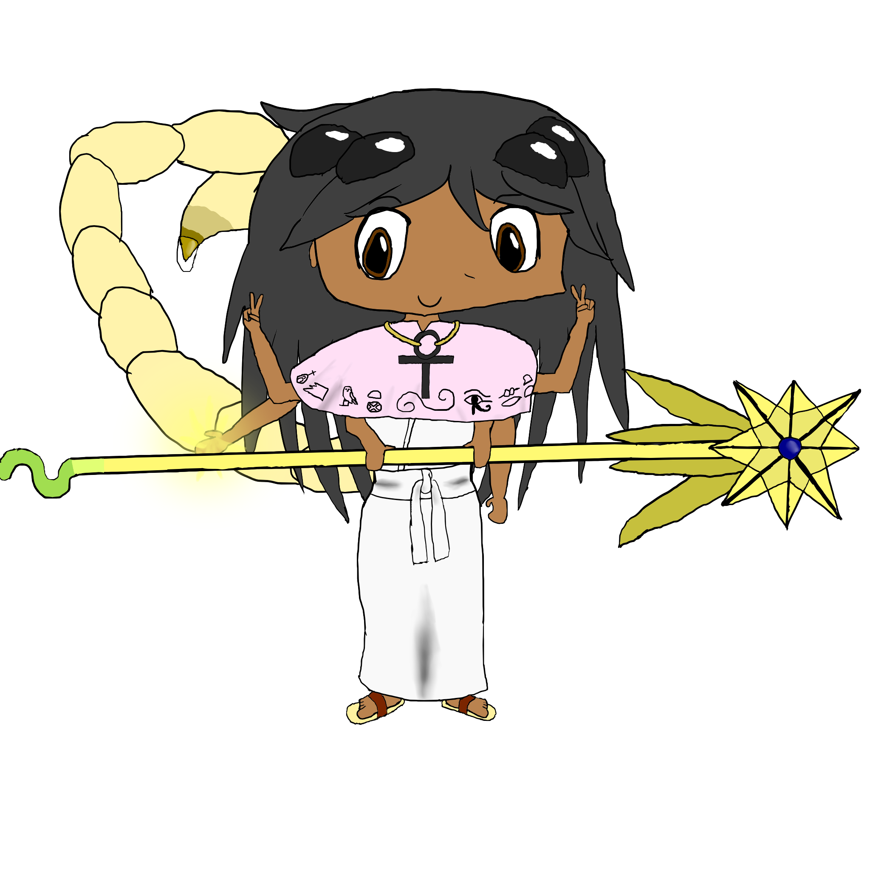
Species: Scorpionoid
Divine Item: Scepter of Truths and Lies
Nationality: Ancient Egyptian
Blood Type: A
Likes: Monster Girls, her research
Dislikes: The Unknown
Scorpion Girl is one of those weird bookish types that have typically been scolded or shunned in the human world just prior to the Great Curse, and there are not many of them that exist in the present world of Monsters and Monster Girls. She is “obsessed with monster girls”, but not in a romantic or sexual way. She is fascinated by the forms that they tend to adopt, and is currently performing a lot of study into the field of the relationship between monster powers and monster girl powers. That said, she is one of the few scholars that exist amongst monster girls, and she documents every encounter she has with monsters and monster girls in a diary-like format, although she includes a lot of useful observations regarding her encounters as well.
Besides her hobbies as a historian and scholar of monster girls, she is also a powerful user of healing magics, which is uncommon for scorpionoids to pursue. She specializes in healing magics that remove afflictions such as poisons and diseases, although she is capable as a more general healer as well. Unfortunately, Scorpion Girl herself suffers from poor vision, which reduces the accuracy of her healing and her full potential. If this limitation were removed, she would be extremely powerful as a healer indeed.
Scorpion Girl inherited the divine item called the Scepter of Truths and Lies, an object thought to be created by the fallen angel Serket herself. After having seen the Scepter at least once, while it remains in the vicinity of the subject, the subject is incapable of lying. However, if the subject's will is stronger than the will of the wielder, the subject is not only capable of lying, but their lies may come true. Scorpion Girl herself is interested in discovering who the fallen angels are, and who made the divine items such as the Scepter of Truths and Lies.
Scorpion Girl's personality can best be described as “obsessive”, although not to a fault. She is certainly interested in pursuing knowledge, but sometimes her behavior can come off as creepy to others. She has a bad habit for explaining things in big words at length, which had alienated many people who could have potentially befriended her. Despite this, she is very knowledgeable about the world and certainly one of the wisest additions to the player party. She is unfortunately very clumsy, probably as a result of her poor eyesight.
Scorpion Girl's true attachment with Serket is unknown, although Serket is responsible for the creation of the scorpionoids amongst monsters, so she may have had a hand in the transformation of Scorpion Girl as well.

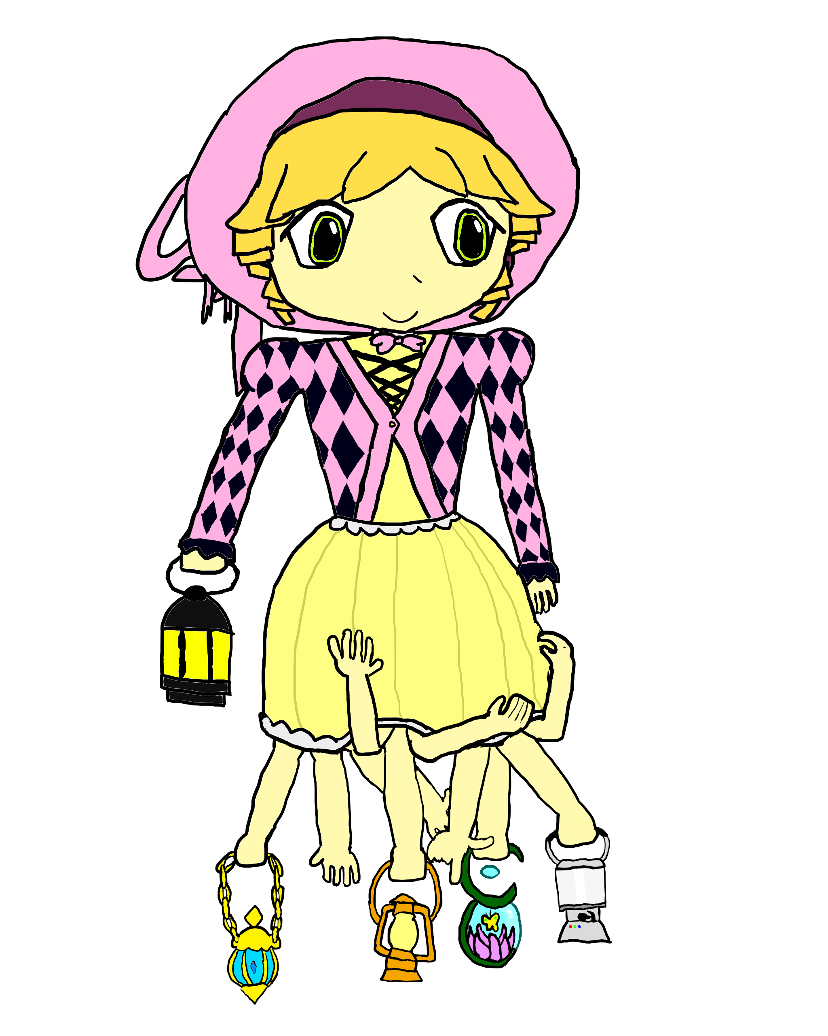
Luciel
Species: Abomination
Nationality: ???
Blood Type: AB
Likes: Lanterns
Dislikes: Losing her lanterns
Luciel is an anomaly among monster girls; she is the Bearer of the Lantern, the Divine Blinding Light, the Harbinger of the Screaming Eye. All of these titles were bestowed upon her by the monsters and monster girls unfortunate enough to confront her and get on her bad side. Eyewitnesses (no pun intended) describe her as a young girl wearing lolita but bearing a lantern with her right arm; but if this description does not reveal what makes her a true abomination, then I'm afraid those people had not gotten the chance to actually see before they were blinded by Luciel's dazzling glow. Thankfully, this is an uncommon occurrence, because Luciel is not as bad as she's often made out to be.
Despite her many titles and her ability, Luciel is actually very affable if you get to figure out how to know her. Communication is a huge barrier for both Luciel and the people she wants to talk to, as she is mute. Instead, Luciel communicates with light signals, sign language, and body language, although the light signals may be hard to transcribe for the uninitiated. If one can understand it, however, it is revealed that Luciel has a very old-fashioned way of speaking. It is likely that if Luciel had a device such as a cell phone, however, she would know how to communicate by text. Her adorable, if abominable, appearance belies her true age and intelligence, however.
The anatomy behind Luciel's dress is unknown and probably unknowable, and is best left to the imagination. Multiple arms appear where her legs would be, however, and they all seem to be controlled by her. Some of these arms are carrying lanterns of different styles and types. In actuality, the lanterns are all connected to Luciel's soul, and it is through that that she is able to modify the intensity and state of each of the lanterns. Luciel is weakened when a lantern is taken away from her, and it appears that she always knows the location of her lost lanterns. Luciel gets very upset when one of her lanterns is lost, however, and the reason for this is unknown; she may be willing to kill to get her lanterns back. It is thought that the lanterns may be her way of sensing the world.
Luciel's preferred method of locomotion is levitating, although she can use her arms to walk if she has to. This method is cumbersome and she is often prone to tripping, since Luciel herself is not used to her own alien anatomy. Luciel is best known for light-based abilities, including, but not limited to, emitting blinding light that will melt the eyes of whoever looks at her, causing total blindness in the hapless onlookers. This light appears to be emitted from her waist down, although its actual source is unknown. In addition, Luciel may bend light rays to appear invisible, create illusions, or concentrate light into lasers that can bring harm to the flesh. Luciel seems to have an understanding of modern technology and is able to interface with it in ways that normal humans cannot, allowing her to achieve unanticipated effects with it. This may be because modern technology relies on light in the form of electromagnetic radiation in order to transmit signals. This suggests that Luciel may also emit or see radiation in other spectrums that require special instrumentation for ordinary humans to see.
The extra arms under Luciel's dress are impractical as combat weapons and Luciel is not dextrous enough to use them to wield weapons, although she may still grapple and strangle foes with them.
Luciel represents the rare subset of monster girls called abomination girls. All abomination girls are unique, and abominations in general cannot be said to be similar or familiar with any other kind of monster. The only known abominations are abomination girls, and it should be noted that not all of them are friendly or safe to be around. Abomination girls tend to embody ancient or eldritch concepts of unknown or abominable natures to monsters. Many abomination girls have alien forms or mindsets that cannot be grasped by monsters or monster girls alike, and some are capable of killing or driving ordinary monsters and monster girls mad. Luciel is different in that she embodies light, which is obsolete in the new world where darkness prevails, and no creature truly needs light to see anymore. As abominations and abomination girls are corrupted by demons as well as the fallen angels, the concepts they embody may similarly be corrupted. In Luciel's case, the light has been corrupted; light had once served as a necessary essence that nearly all creatures needed, for in its absence, nothing can see, and therefore everything is lost. Light has lost this good purpose in the new world, where it has instead become a dangerous force that can drive things to blindness, although perhaps its other functions (i.e. signaling and fiber optics) have not truly been lost yet.

Minotaur Girl
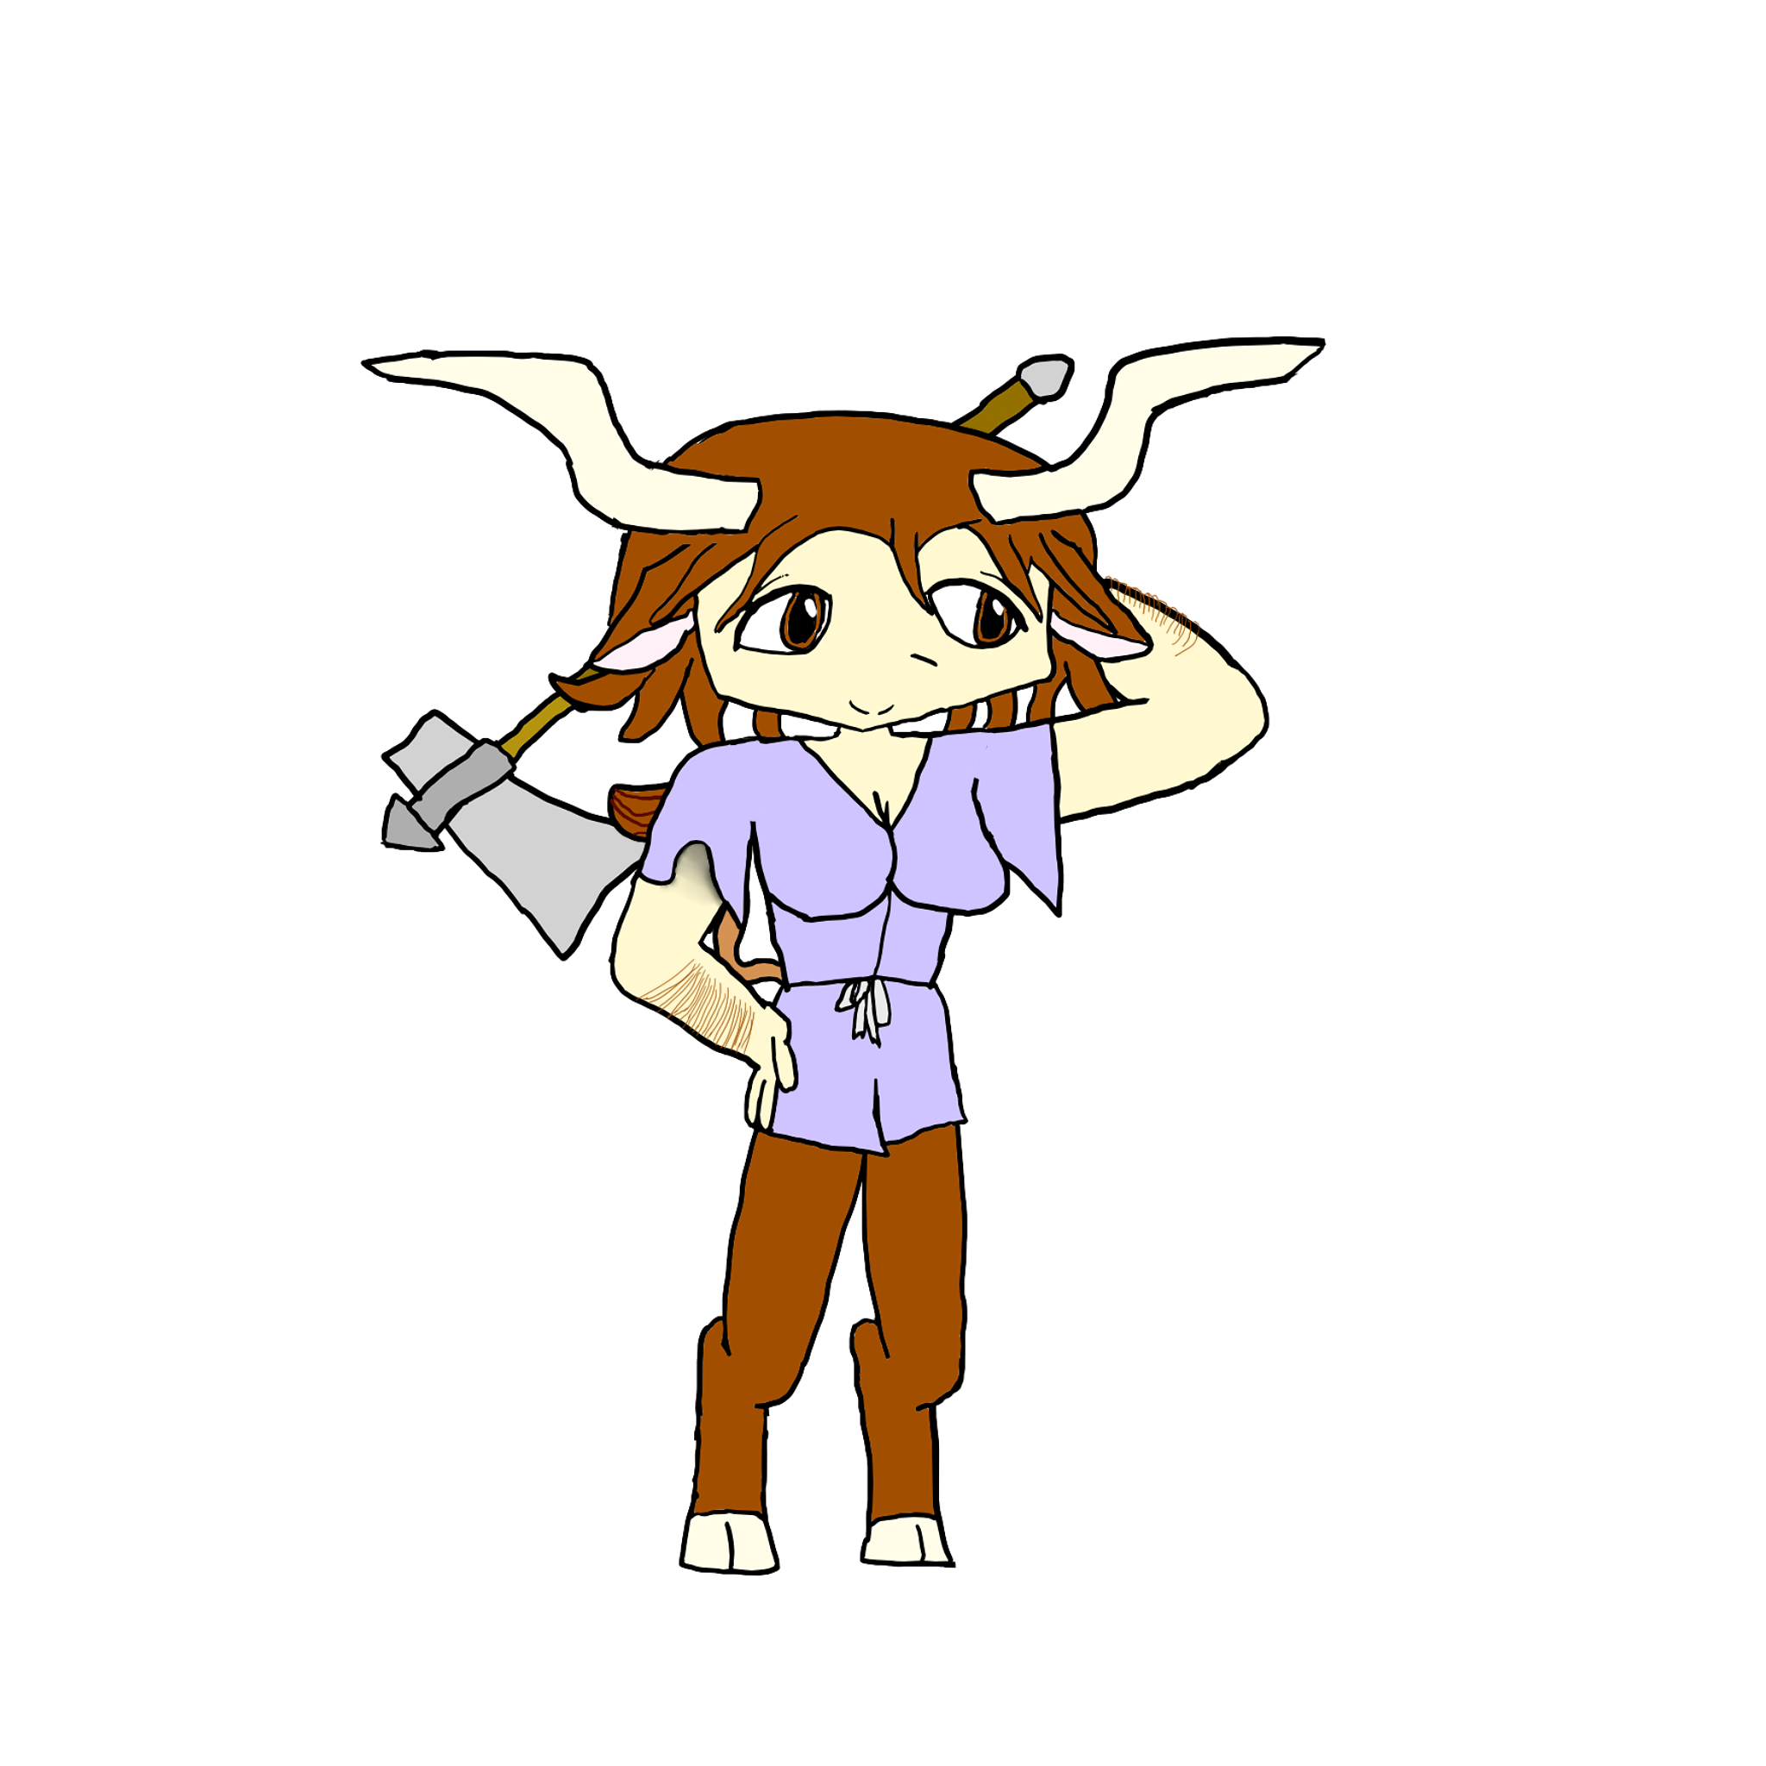

Gargoyle Girl
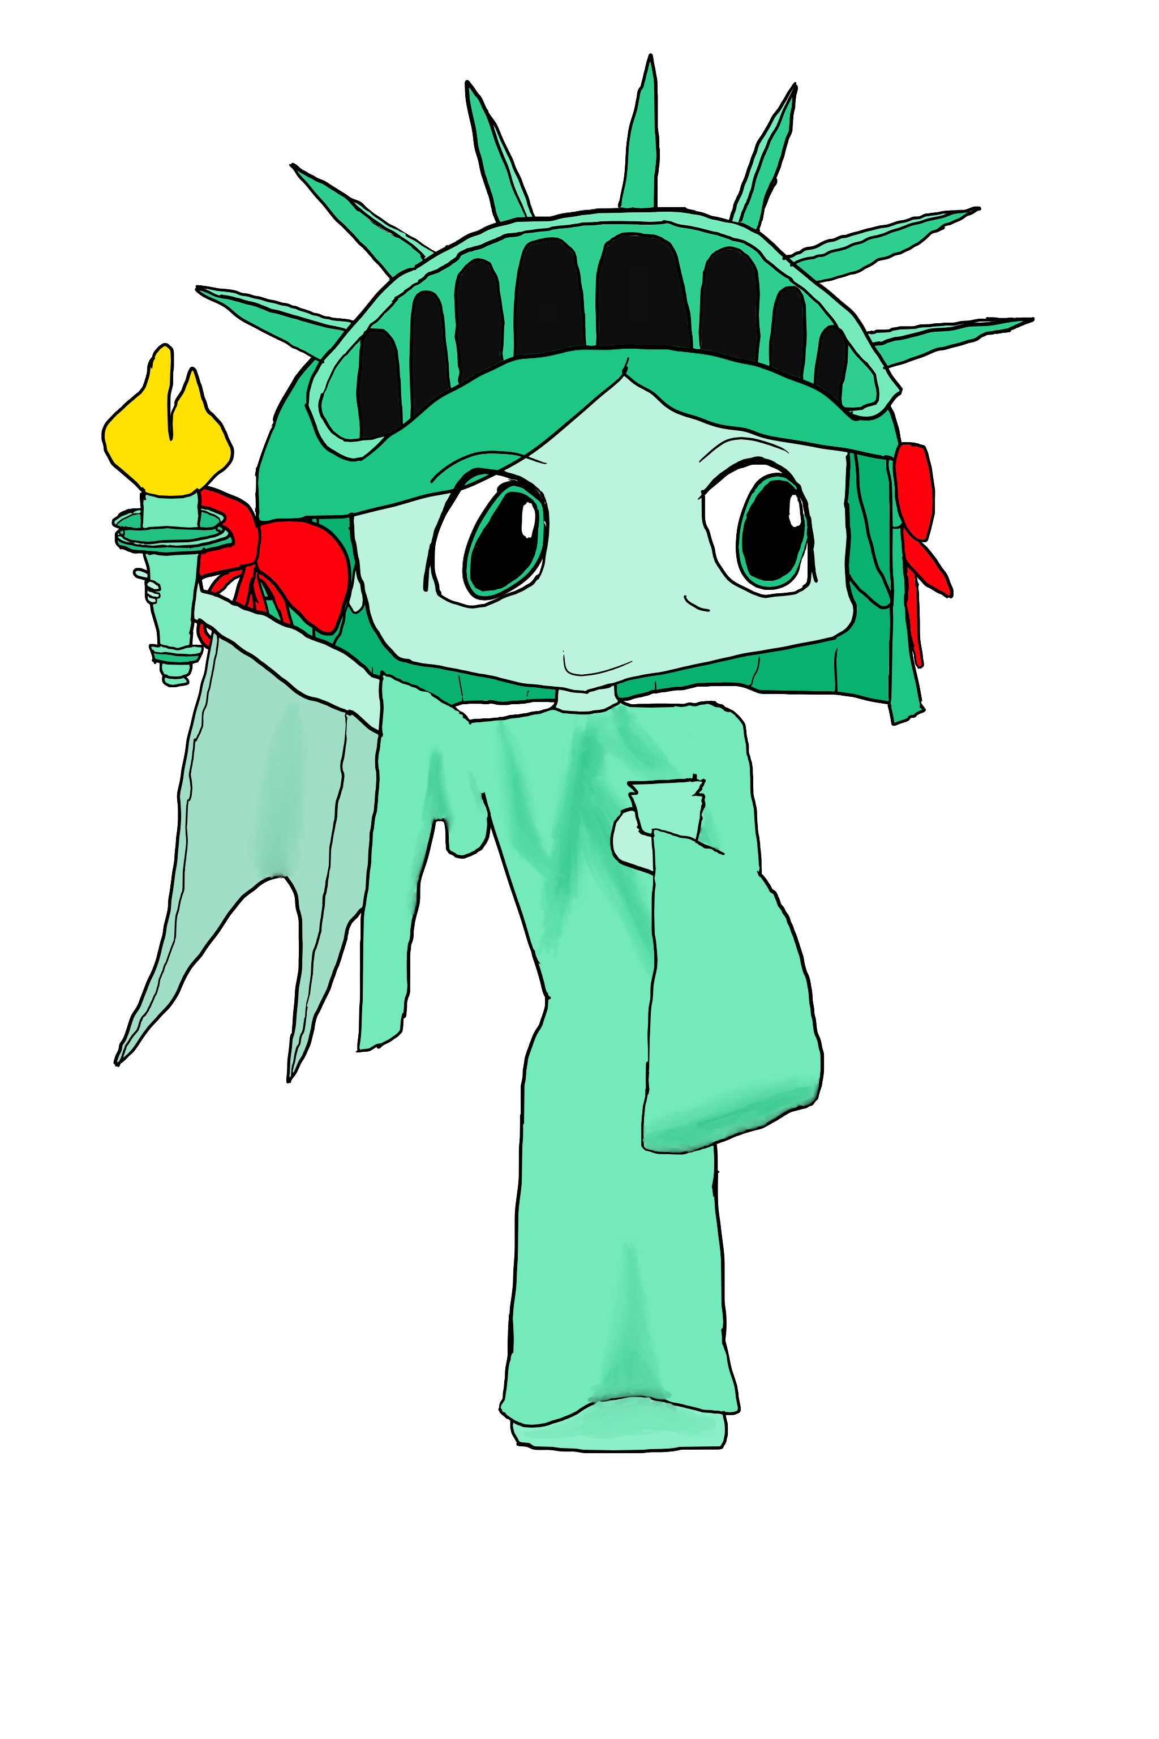

Werewolf Girl

Hydra Girl
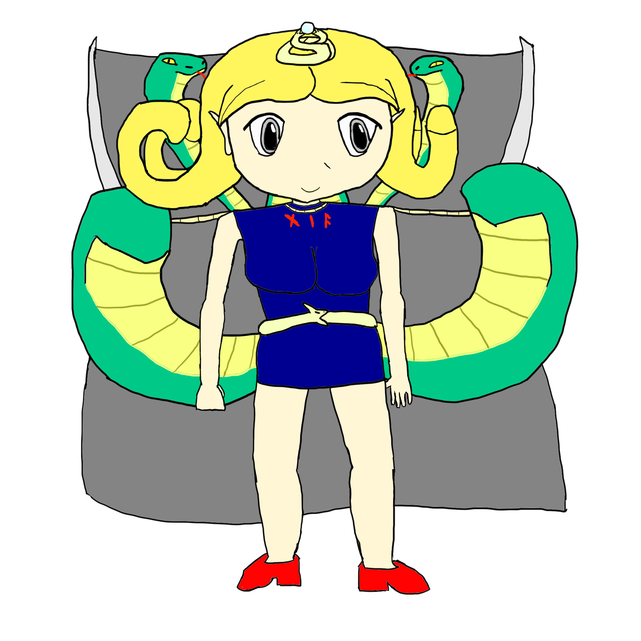
Species: Hydra
Nationality: Greek
Blood Type: O
Likes: Ice cream
Dislikes: Her mother and sisters, spicy foods
Before the events of the Great Curse, Tiamat was said to be a beautiful woman. She was so beautiful and charismatic, she was able to persuade any man of any social status into marrying her. She used the riches of her husbands and boyfriends to dwell in a life of debauchery and excess. She had born many children to these men; all girls, and all were just as horribly-natured as she was; this is true except for one girl, who later became Hydra Girl. This girl was different from the rest of her sisters; she wasn't interested in bullying others for her own amusement. When her mother would come home drunk, all of Tiamat's daughters were punished for no apparent reason, giving them arbitrary house chores, being grounded, or even viciously beaten up. The other sisters took out their rage on each other, but Hydra Girl bore the brunt of this abuse. Hydra Girl became quiet and subservient as a result of this abuse but did not feel the desire to retaliate because she didn't understand why she would want to make others feel her pain. Because of her quiet resignation to this abuse without retaliation, Hydra Girl's mother Tiamat actually favored her the most for her resilience, but this parental favoritism only gave way to jealousy in the other sisters, who now loathed Hydra Girl even more. Despite Tiamat's favoritism towards Hydra Girl, however, Hydra Girl felt that her mother couldn't justify her abuse and had to fix her problems in her life.
One day, Tiamat and her family were on a private yacht owned by her husband out on the high seas for a dual recreational/business trip. One day, however, a powerful hurricane swept through the area and the family was not able to prepare for it, anticipating that the weather would be good throughout their voyage. Some unidentified large object adrift at sea was tossed by the wind and struck the ship's hull, causing the yacht to capsize. Everybody else on board had perished, but Tiamat and her daughters merely fell into the ocean and drifted towards the bottom, unconscious, but not drowning. Their forms had changed into the forms of the horrid hydras told in Greek legends. For Hydra Girl, however, the transformation was incomplete, as while she grew three large tails and two additional snake heads, she was still recognizably human. When Hydra Girl and the others regained consciousness, Hydra Girl saw the dark and terrible things that lie in the deeps of the sea under the nose of mankind. She was chased out by her sisters, who promised to hunt her down until she was dead, and blamed Hydra Girl for turning them into monstrous beings.
Hydra Girl is one of the monster girls that joins the party early in the game. She acknowledges that her mother had created a cult centered around her and is in league with Great Babylon, so she has aligned herself against her mother, who hadn't seen her since she was transformed. Hydra Girl has always been a calm and collected person, although because she realizes that the world is not always as it seems, she changes her behavior around others in order to blend seamlessly with her peers. On the exterior, Hydra Girl seems to be a girl that lacks any common sense. Hydra Girl is patient, and is waiting for the opportunity to strike back at her mother and sisters in order to get serious. Hydra Girl is often holding back her power, allowing herself to get beaten; if it weren't for her healing factor, she would have died many times over a long time ago. The other girls rarely take Hydra Girl seriously and find her incompetent at performing basic tasks in combat, so she is often ignored in the main party. Hydra Girl is, however, very powerful, and quite capable of taking on hordes of monsters herself, although she wouldn't display this power until it's actually needed, because she is testing the monster girls to see if they are fully capable of handling Tiamat.
Hydra Girl represents the abominable and monstrous species called the hydra. All known hydra are the spawn of Tiamat, which is also Hydra Girl's mother. Hydras have the ability to regenerate rapidly and can take quite a beating before falling in combat. Severed heads regrow back very quickly, although if all heads are severed before any can grow back, the hydra will die. The older a hydra gets, the more heads it will have, and the oldest hydras in existence, including Tiamat, have 12 heads. Hydra Girl has two other heads that influence her thoughts to an extent, but Hydra Girl otherwise thinks independently. In addition, hydras have the ability to breathe different breaths through their many heads; usually either fire, ice, or electricity. Hydra Girl is capable of breathing any of those three.

Emperor Belial

This monster is the first emperor of the Empire of Great Babylon, coming to unite all the disparate and warring monster factions into one unified entity through force and fear. He has been successful in uniting many of the monsters in the world because he exploits their hatred of the less corrupted monster girls. His goal is to exterminate the monster girls once and for all in order to usher in the Final World of Darkness that Satan convinces him is the only worthwhile outcome for the world.
Belial holds the divine item called the Orb of Divinity, which is said to be able to make someone holding it “like a god”. Although it definitely gives one the impression that one has become all-powerful, it is likely that the described effect is merely a placebo for the user to make them feel like they're a god. On the other hand, using this item is said to corrupt one's soul so greatly that one's true monstrosity appears.
Belial is a frog-man, an amphibious being with the power to breathe underwater. Despite this fact, most frog-men actually look more like anthropomorphized toads. They are among the weaker specimens of monsters that exist, although Belial is exceptional in that he is only mildly stronger than others of his kind. Frog-men also tend to exude toxins from their body that are cytotoxic in effect.

Ishtar

Ishtar is Belial's right-hand woman when it comes to handling most day-to-day affairs. All too often, Belial is simply too bad tempered to handle most things on his own, and he is rarely competent or patient. Where Belial lacks in these areas, Ishtar surpasses him, and that is what makes her dangerous.
Ishtar is one of the fallen angels who has decided to fight on the side of evil in Armageddon, so she pledged allegiance to the most powerful monster of them all. However, little does Belial know, Ishtar is fully capable of taking over if she wanted to, but she has not done so yet, possibly because of laziness or wanting to see where Belial will take the empire.
Ishtar possesses the divine item called the Goblet of Kings and Saints, which is said to hold the blood of every martyr that has ever died, including Jesus himself. The person that drinks from the goblet is said to become drunken with great power, and it is quite true that Ishtar herself is quite drunken with this power.

Tiamat

Tiamat is one of the greatest monsters produced by the Great Curse; a seven-headed hydra whose size dwarfs most monsters. The Empire of Great Babylon endorses a cult with her at the center, for she is possibly the most powerful monster in existence. It is said that she and her spawn have emerged from under the darkest depths of the sea.
The hydras encompass her spawn. Hydras are great serpentine beasts of many heads that have the ability to heal very quickly. Notably, among her spawn include Hydra Girl, who refuses to associate with her in any way.

Baphomet

Baphomet is the second greatest of the monsters produced by the Great Curse, but he is not great by power. Baphomet is the highly charismatic administrator of Tiamat, whose servants process documents such as currency bearing the Mark of Tiamat. He is said to have emerged from underneath the earth to spread lies to the peoples of the lands.
The minotaurs encompass his spawn, although Baphomet himself looks like a literal handsome devil with cloven hooves and goat horns. He is able to turn into a mighty and powerful minotaur form at will, although even in this form he is nowhere near as powerful as Tiamat.

Dragobearasaurus Rex

This monster is the king of the beasts, the most widely feared unintelligent creature in existence. It is so aggressive, so vicious, and so hungry, that even the hierarchy of New Babylon have taken extreme measures to avoid this colossal creature's onslaught. A team of monster girls have since managed to use powerful magic to tranquilize it and trap it underground, but there's no telling what this beast will do when it wakes up...
It is essentially a mix between a fire-breathing dragon, a tyrannosaurus rex, and a bear. This creature constitutes the game's main bonus boss, although the path to reach it is not very straightforward. The dragobearasaurus rex is harder than the game's final boss, but it is thankfully optional and killing it provides a unique scenario.

